Struts 2 Architecture:
Struts2 is MVC based framework. The Model-View-Controller pattern consists of following five core components:
- Actions
- Interceptors
- Value Stack / OGNL
- Results / Result types
- View technologies

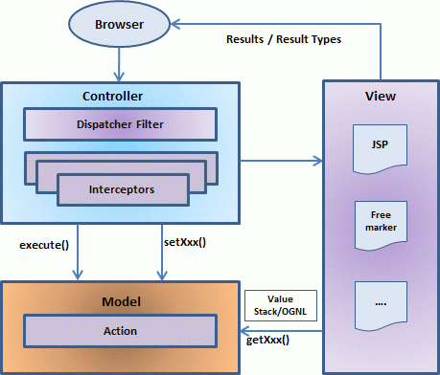

Request life cycle:
- User sends a request to the server for requesting for some resource (i.e pages).
- The FilterDispatcher (Front Controller in struts2) looks at the request and then determines the appropriate Action.
- Configured interceptors are applied for data conversion, validation, file upload etc.
- Selected action is executed to perform the requested operation.
- Again, configured interceptors are applied to do any post-processing if required.
- Finally the result is prepared by the view and returns the result to the user.

